|  |  |
| --- | --- |
| File:COMSATS new logo.jpg - Wikimedia Commons  Class Assignment - 03 | **submitted by:**  **Shahzaneer Ahmed**  (Sp21-BCS-087)  **submitted to:**  **Mr. Rizwan Rashid**  **date of submission:**  **December 19th, 2021** |

Question 1

# Source Code

*//------------------------------------------------------------------  
//--------------------SHAHZANEER AHMED------------------------------  
//-----------------------SP21-BCS-087-------------------------------  
//-----------------------Class Assignment---------------------------  
//-----------------------Question 1---------------------------------  
//------------------------------------------------------------------  
  
//Question – 1: ______  
// Write a JAVA Program to Multiply Two Matrix Using Multi-Dimensional Arrays. This program  
// takes two matrices of order r1*c1 and r2*c2 respectively. Then, the program multiplies these two  
// matrices (if possible) and displays it on the screen.  
  
import java.util.Scanner*;  
*public class Question1* {  
 *public static void* main(*String*[] *args*) {  
 *Scanner* input = *new* Scanner(*System*.in);  
 *while* (*true*) {  
  
*// input of dimensions of matrices.  
 System*.out.println("Enter the number of rows in first Matrix");  
 *int* r1 = input.nextInt();  
 *System*.out.println("Enter the number of columns in first Matrix");  
 *int* c1 = input.nextInt();  
 *System*.out.println("Enter the number of rows in Second Matrix");  
 *int* r2 = input.nextInt();  
 *System*.out.println("Enter the number of columns in Second Matrix");  
 *int* c2 = input.nextInt();  
  
 *if* (c1 == r2) {  
  
 *int* [][] Matrix_1 = *new int* [r1][c1];  
 *int* [][] Matrix_2 = *new int* [r2][c2];  
 *int* [][] newMatrix = *new int*[r1][c2];  
 *int* r3 = r1;  
 *int* c3 = c2;  
  
 *int* row_m1 ,column_m1, row_m2,column_m2;  
  
 *System*.out.println("The Matrix Multiplication is possible !");  
 *System*.out.printf("Enter the constituents of First Matrix | A %dx%d Matrix \n",r1,c1);  
*// taking input in first matrix;  
 for*( row_m1 = 0; row_m1<r1; row_m1++){  
 *for* (column_m1 = 0; column_m1<c1; column_m1++){  
 *System*.out.printf("Enter element at %dth row %dth column ",row_m1+1,column_m1+1);  
 Matrix_1[row_m1][column_m1] = input.nextInt();  
 }  
 }  
  
 *System*.out.printf("Enter the constituents of Second Matrix | A %dx%d Matrix \n",r2,c2);  
*// input in second Matrix;  
 for*( row_m2= 0; row_m2<r2; row_m2++){  
 *for* (column_m2 = 0; column_m2<c2; column_m2++){  
 *System*.out.printf("Enter element at %dth row %dth column ",row_m2+1,column_m2+1);  
 Matrix_2[row_m2][column_m2] = input.nextInt();  
 }  
 }  
  
*// Main Multiplication Logic ..  
 for* (*int* i = 0; i<r3; i++){  
 *for*(*int* j = 0; j<c3;j++){  
 newMatrix[i][j] = 0; *//so that no garbage value can effect the multiplication.  
 for*(*int* k = 0; k<c1; k++){  
*// traversing k liay jo bhi cheez same houti hai wo use houti hai yani multiplication ki  
// condition use hoti hai r2 ya c1 dono main se koi bhi use hoskta hai.  
// hamain pta hai k matrix1 ki row ko matrix2 k column se multiply krna hai lekin dono  
// cheezain alag alag nhi hotin mazeed inke saath specify krna houta hai dusre parameter  
// ko jo condition wala houta hai so yun hm matrix 1 main row ko ith aur matrix 2 main  
// column ko jth position dete hain aur dusre factor main hum dono jagah same value  
// (multiplication ki condition ya tou r2 ya c1)  
// dengay* newMatrix[i][j] = newMatrix[i][j] + Matrix_1[i][k] * Matrix_2[k][j];  
  
 }  
 }  
 }  
  
 *System*.out.println("The new Matrix is :");  
 *for* (*int* i = 0; i<r3; i++){  
 *for*(*int* j = 0; j<c3;j++){  
 *System*.out.print(newMatrix[i][j]+" ");  
 }  
 *System*.out.println();  
 }  
 *System*.*exit*(0);  
  
 }  
  
 *else* {  
 *System*.out.println("The Matrix Multiplication isn't possible.\nThe number of columns in first matrix " +  
 "should be equal to the number of columns in second matrix");  
 *System*.out.println("Do you want to enter another Matrix? y or n");  
 *String* option = input.next();  
 *if* (option.equalsIgnoreCase("y")) *continue*;  
 *else if* (option.equalsIgnoreCase("n")) *System*.*exit*(0);  
  
 }  
  
 }  
 }  
}

# Output

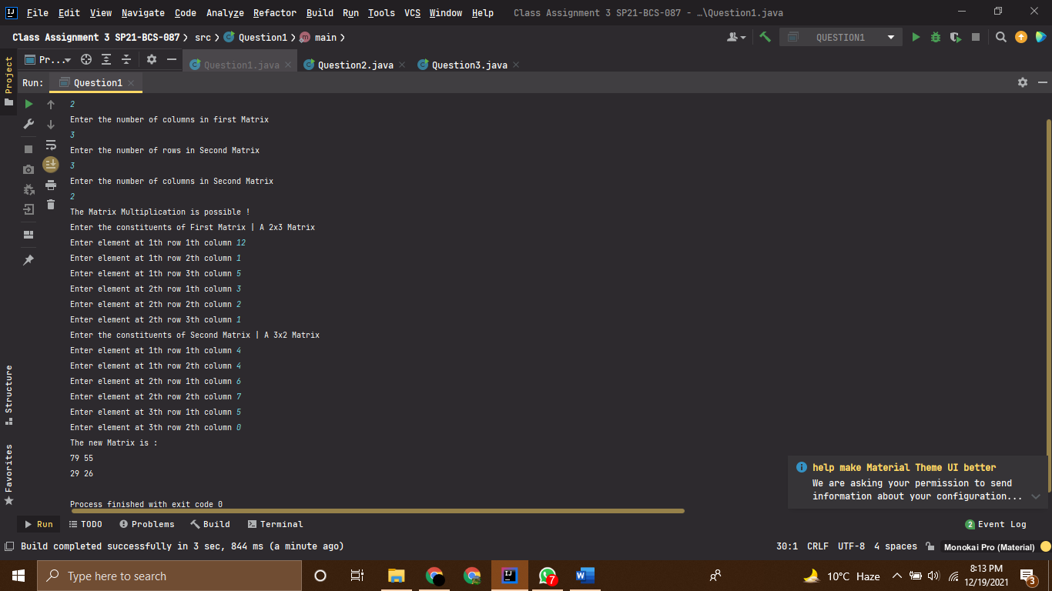

Question 2

# Source Code

*//------------------------------------------------------------------  
//--------------------SHAHZANEER AHMED------------------------------  
//-----------------------SP21-BCS-087-------------------------------  
//-----------------------Class Assignment---------------------------  
//-----------------------Question 2---------------------------------  
//------------------------------------------------------------------  
  
//Question – 2: ______  
// An array my_Array[] consisting ‘a’ s, ‘b’ s and ‘c’s. The task is to write a method that arranges  
// the array such that all ‘a’s are placed first, then all ‘b’s and then all ‘c’s in last.  
  
import java.util.Arrays*;  
  
*public class Question2* {  
 *public static void* main(*String*[] *args*) {  
 *char* [] my_Array = {'a','b','a','c','b','a','a','c','b'};  
 *// arrays containing character a's , b's , c's .  
// System.out.println((int)'a'); //the ascii code for characters a , b and c are 97,98,99 respectively.  
// we can compare them as integers and the comparison will take place in view of their ASCII equivalents.  
  
// System.out.println(('a'>'b')); //as 97>98 always returns to be false  
 arrangeArray*(my_Array);  
 *System*.out.println(*Arrays*.*toString*(my_Array));  
  
*// built-in Method to sort a character Array!  
// Arrays.sort(my_Array);  
// System.out.println(Arrays.toString(my_Array));* }  
 *static void* arrangeArray(*char* [] *array*){  
  
 *for* (*int* i = 0; i<*array*.length;i++){  
 *for*(*int* j = i+1; j<*array*.length;j++){  
 *if* (*array*[i] > *array*[j]){  
 *char* temp;  
 temp = *array*[i];  
 *array*[i] = *array*[j];  
 *array*[j] = temp;  
 }  
 }  
 }  
 }  
  
}

# Output

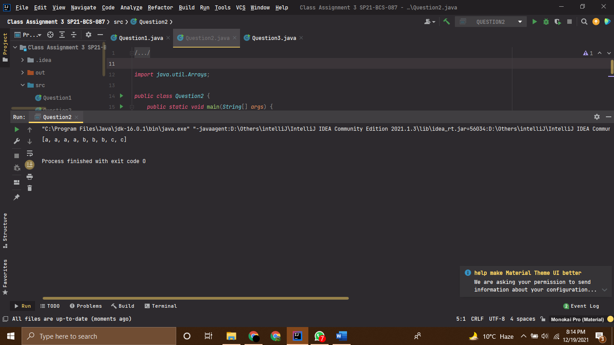

Question 3

# Source Code

*//------------------------------------------------------------------  
//--------------------SHAHZANEER AHMED------------------------------  
//-----------------------SP21-BCS-087-------------------------------  
//-----------------------Class Assignment---------------------------  
//-----------------------Question 3---------------------------------  
//------------------------------------------------------------------  
  
//Question – 3: ______  
// Write a Menu Driven JAVA program that creates one-dimensional array arr[] and initialize it  
// with user. The program should do following Tasks using Menu, the menu operations are  
// implemented using methods:  
// 1. Write a method count(), that counts the occurrences of x (a number) in arr[].  
// 2. Write a method partition(), that take the first element of the array x and put x in a  
// position such that all smaller elements (smaller than x) are before x, and put  
// all greater elements (greater than x) after x.  
// 3. Write a method duplicates(),which calculate the frequencies of all the elements  
// and display them.  
// 4. Write a method circular(),which replace every element of the array by the sum of  
// next two consecutive elements in a circular manner i.e.  
// arr[0] = arr[1] + arr[2], arr[1] = arr[2] + arr[3], … arr[n – 1] = arr[0] + arr[1].  
// 5. Write a method shiftCircular(), which shifts an array circularly left by two  
// positions. Thus, if p[0] = 15, p[1]= 30, p[2] = 28, p[3]= 19 and p[4] = 61 then  
// after the shift p[0] = 28, p[1] = 19, p[2] = 61, p[3] = 15 and p[4] = 30  
  
import java.util.Arrays*;  
*import java.util.Scanner*;  
*public class Question3* {  
 *public static void* main(*String*[] *args*) {  
 *Scanner* input = *new* Scanner(*System*.in);  
 *System*.out.println("Enter the size of array :");  
 *int* size = input.nextInt();  
 *int*[] array = *new int*[size];  
 *System*.out.println("Enter the Elements of array ");  
  
 *for* (*int* i = 0; i < array.length; i++) {  
 *System*.out.printf("Enter element at %d index : ", i);  
 array[i] = input.nextInt();  
 }  
  
 *while* (*true*) {  
 *System*.out.println("Enter corresponding number to find the result :");  
 *System*.out.println("""  
 1. Count the Appearance of an element (x).  
 2. Partition (takes the first element and shifts smaller elements to left and greater on right)  
 3. Duplicates (Frequency of each element in array)  
 4. Circular (prints the sum of next two terms at ith position WRT array indexing)  
 5. ShiftCircular (shifts two positions the elements to left)  
 6. Exit  
 """);  
 *int* selection = input.nextInt();  
  
 *if* (selection == 6) *System*.*exit*(0);  
  
 *switch* (selection) {  
 *case* 1 -> *counts*(array);  
 *case* 2 -> *partition*(array);  
 *case* 3 -> *duplicate*(array);  
 *case* 4 -> *circular*(array);  
 *case* 5 -> *shiftCircular*(array);  
  
 }  
 }  
  
 }  
 *static void* shiftCircular ( *int*[] *array*){  
 *int*[] shiftCircularArray = *new int*[*array*.length];  
 *for* (*int* i = 0; i < *array*.length; i++) {  
 shiftCircularArray[i] = *array*[((*array*.length + (i - 3)) % *array*.length)];  
 }  
  
 *System*.out.println(*Arrays*.*toString*(shiftCircularArray));  
  
 }  
  
 *static void* circular ( *int*[] *array*){  
 *int*[] arrayCircular = *new int*[*array*.length];  
 *for* (*int* i = 0; i < *array*.length; i++) {  
 arrayCircular[i] = *array*[(i + 1) % *array*.length] + *array*[(i + 2) % *array*.length];  
 }  
  
 *System*.out.println(*Arrays*.*toString*(arrayCircular));  
  
 }  
  
 *static void* duplicate ( *int*[] *array*){  
 *int*[] visitedArray = *new int*[*array*.length]; *//creating array of equal size as of array.  
 int* visited = -1; *//a flag value to be used at the index of visitedArray if the element is already visited!  
  
 for* (*int* i = 0; i < *array*.length; i++) {  
 *int* count = 1;  
 *for* (*int* j = 1 + i; j < *array*.length; j++) {  
 *if* (*array*[i] == *array*[j]) {  
 count++;  
 visitedArray[j] = visited;  
 }  
 }  
  
 *if* (visitedArray[i] != visited) {  
 visitedArray[i] = count;  
 }  
 }  
  
 *for* (*int* i = 0; i < *array*.length; i++) {  
 *if* (visitedArray[i] != visited) {  
 *System*.out.printf("The frequency of %d in array is %d \n", *array*[i], visitedArray[i]);  
 }  
 }  
 }  
  
  
 *static void* partition ( *int*[] *array*){  
 *int* target = *array*[0];  
 *int* countTargetGreater = 0;  
 *int* countTargetSmaller = 0;  
 *int* counterTarget = 0;  
  
 *for* (*int* i = 0; i < *array*.length; i++) {  
 *if* (*array*[i] > target) countTargetGreater++;  
 *else if* (*array*[i] < target) countTargetSmaller++;  
 *else if* (*array*[i] == target) counterTarget++;  
 }  
 *int*[] greaterElements = *new int*[countTargetGreater];  
 *int*[] smallerElements = *new int*[countTargetSmaller];  
 *int*[] targetElements = *new int*[counterTarget];  
  
  
 *int* greaterElementsIndex = 0;  
 *for* (*int* i : *array*) {  
 *if* (i > target) {  
 greaterElements[greaterElementsIndex] = i;  
 greaterElementsIndex++;  
 }  
 }  
  
 *int* smallerElementsIndex = 0;  
 *for* (*int* i : *array*) {  
 *if* (i < target) {  
 smallerElements[smallerElementsIndex] = i;  
 smallerElementsIndex++;  
 }  
 }  
  
 *int* targetElementsIndex = 0;  
 *for* (*int* i : *array*) {  
 *if* (i == target) {  
 targetElements[targetElementsIndex] = i;  
 targetElementsIndex++;  
 }  
 }  
*// now filling the required array!  
 int*[] partitionArray = *new int*[greaterElementsIndex + smallerElementsIndex + targetElementsIndex];  
  
*// copying elements in index;  
// System.arraycopy(smallerElements,0,partitionArray,0,smallerElementsIndex);  
// System.arraycopy(targetElements,0,partitionArray,smallerElements.length,targetElements.length);  
// System.arraycopy(greaterElements,0,partitionArray,targetElements.length,greaterElements.length);  
  
 int* index = 0;  
 *for* (*int* i : smallerElements) {  
 partitionArray[index] = i;  
 index++;  
 }  
 *for* (*int* i : targetElements) {  
 partitionArray[index] = i;  
 index++;  
 }  
 *for* (*int* i : greaterElements) {  
 partitionArray[index] = i;  
 index++;  
 }  
  
*// displaying  
 System*.out.println(*Arrays*.*toString*(partitionArray));  
  
  
 }  
  
 *static void* counts ( *int*[] *array*){  
 *Scanner* input = *new* Scanner(*System*.in);  
 *System*.out.println("Enter the number whose occurrence you want to find :");  
 *int* number = input.nextInt();  
 *int* counter = 0;  
 *for* (*int* j : *array*) {  
 *if* (j == number) counter++;  
 }  
 *System*.out.printf("The number %d appeared %d times in the array !\n", number, counter);  
 }  
  
}

# Output

